Writing 5
- Statement
Our project focuses on the London Eye. We try to use design to help people with disabilities experience the London skyline with different senses and enjoy the process of riding the London Eye. After integrating field research and discussion, we made a portable wearable device. We drew illustrations of city street scenes and presented the illustrations on the turntable in the form of relief. Visually impaired people can wear this device and rotate the turntable to feel the London skyline with touch and experience the London skyline with sound. We try to break the traditional visual viewing mode and allow the visually impaired to experience the London skyline through touch and audio, so that they can "watch" the city scenery independently. During the research process, we collected all the environmental sounds that can be heard when riding the London Eye, and edited and layered them to provide a more immersive auditory experience for the visually impaired.
This project made me understand that barrier-free design is expansion rather than restriction. Our goal is to enable people with disabilities to fully experience space without physical restrictions. After this course, I will continue to explore how to help people with disabilities transform different ways of perception through barrier-free design, so that everyone can experience and build their own urban memories equally.

- References

2 from Reading list:
·Conditional Design Workbook

After researching the Conditional Design Workbook, I focused more on how a rules-based design approach can improve accessible experiences. The book discusses how design can be used to create interactive and open-ended experiences that are based on pre-determined conditions and system structures. This philosophy has strongly influenced my London Eye Accessibility Experience project, leading me to focus more on how visual information can be transformed through touch and sound to enable visually impaired people to actively explore urban spaces rather than passively receive information.

My design follows the principles of 'visual → tactile' and 'visual → auditory' transitions. The London skyline is rendered in embossed textures, allowing the user to identify the relative position of buildings by touch. At the same time, I borrowed Conditional Design's method of information hierarchy and designed layered audio, combining ambient sound, directional audio and narration, so that users could dynamically construct their own cognitive paths rather than passively follow a fixed process. Conditional design also got me thinking about how to optimise the interaction mechanisms. We wanted to introduce more personalised navigation options, such as voice interaction or haptic feedback, to guide the user in choosing how to read the information.

·Invisible Cities

Italo Calvino's Invisible Cities argues that the city is not only a collection of physical spaces, but also multiple experiences interwoven through memory, perception and imagination (Calvino, 1974). While he translates the city into language, my project translates the visual experience by touching and sounding, making it accessible to the visually impaired.

Calvino (1974) emphasises that the meaning of the city lies not only in the architecture itself, but in the relationship between people and space. The accessibility of a city depends not only on the physical infrastructure, but also on how people perceive and interact with it. In our project, by constructing a more inclusive viewing experience that allows the visually impaired to 'feel' the London skyline through touch and sound, we have sought to break away from the traditional visual dominance of the city.

Rather than simply providing audio-visual information, our design creates a space for autonomous exploration where the visually impaired can construct their own perceptions of the city, rather than being passive recipients of interpretation. This design concept embodies the core ideas of Invisible Cities about urban mobility and individualised experience, so that the city is no longer a visual space, but an experiential space that can be perceived and interpreted through multiple senses.

Reference List:
Calvino, I. (2010) Invisible Cities. Vintage Digital.

2 outside from Reading list:
·The world is unknown

Carolyn Lazard's work focuses on discussions of the relationship between the body, behaviour and social phenomena. She challenges society's inherent definitions of health and productivity in the context of physical health, trauma and healing. In The World is Unknown, Lazard(2019) points out that the mind is not separate from the body, but part of it, and emphasises how beliefs and perceptions can influence people's understanding of their own health. This ties in with our group's design theme, the London Eye Accessibility Experience, which led us to explore how multi-sensory design can break down traditional perceptual boundaries and help visually impaired people to 'see' London.

Lazard's work has a strong emphasis on the diversity of perception and her advocacy of different ways of understanding things that cannot be perceived through traditional cognitive systems(Lazard, 2019). In our group project we want to break through the visual experience of the cityscape and construct it through the senses of touch and sound. This will enable disabled people to construct and experience social environments and spaces through their other senses. In our project we argue that by transforming information from different senses, urban space can become a medium for all people to interact, experience and construct their own memories.

Reference List:
Lazard, C. (2019) The World is Unknown. Triple Canopy. Available at: https://canopycanopycanopy.com/contents/the-world-is-unknown (Accessed: [insert date]).

·On Paralysis, Part 1

After reading the article On Paralysis, Part 1, we further discussed the relationship between the body and the social environment, and how social structures restrict the rights of people with disabilities. The article On Paralysis explores how technology enhances or restricts physical capabilities, emphasizing that paralysis is not just a physiological limitation, but also a social phenomenon exacerbated by the social environment. The author attempts to call on us to re-examine our understanding of physical capabilities and advocates creating a more inclusive social environment through barrier-free design and changing social policies.

In our project, we hope to provide visually impaired people with tactile and auditory experiences that can replace vision through multi-sensory design, so that they can experience the London skyline independently without direct introduction from the outside world. In the process of drawing city illustrations and carving city street scenes, we constantly explore artistic techniques that can help people with disabilities to recognize more easily and make continuous adjustments. When carving, I kept closing my eyes, trying to feel the city image with touch, and manually adjusting it. In this process, I realized that barrier-free design not only supplements the functionality of social public facilities, but also defends the fair social rights of people with disabilities.

If this project can continue to develop, we imagine that it can be developed into a personalized tour that combines touch and dynamic audio. We hope that this tour can give the visually impaired the ability to actively explore the environment, and in the future, make the city experience of people without disabilities more immersive and interactive.

Reference List:
Williams, E. C. (2024) ‘On Paralysis, Part 1’, e-flux Journal, (141). Available at: https://www.e-flux.com/journal/141/579867/on-paralysis-part-1/ (Accessed: [27 February 2025]).

- design projects:
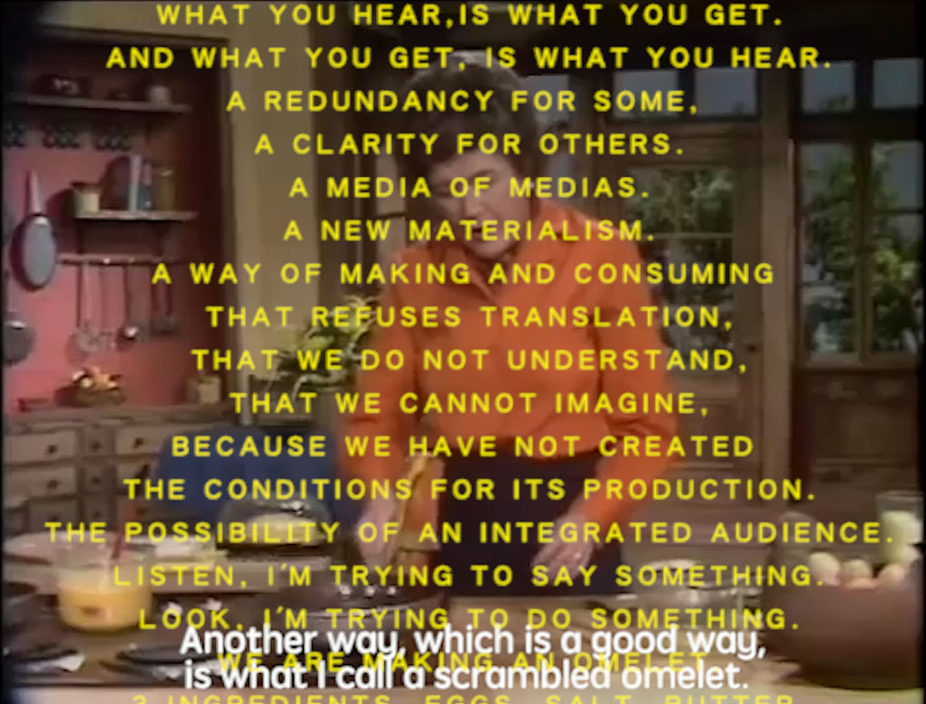
·a recipe for disaster
A Recipe for Disaster, 2018

Recipes for Disaster loops a clip of Julia Child scrambling eggs from The French Chef (one of the first shows to provide real-time subtitles for impaired viewers). Carolyn Lazard criticized the barriers that mass media set up in the dissemination of information, making accessibility difficult. The artist also further improved the video, cleverly combining sound, text, and images, and put the sound of her own recorded monologue and the host's scrambled eggs on the show together for comparison, allowing blind and visually impaired viewers to not only hear the content, but also perceive the information on the picture more clearly through the layering of sound.

Inspired by this project, our design explores how to make sound part of the spatial narrative
Our group collaboration project attempts to provide new ways of exploration for the visually impaired. In our London Eye Accessibility Experience project, we borrowed Lazard's method of using sound to shape experience and promote the concept of accessibility as a wider social infrastructure. In the project, we tried to break the traditional viewing mode and allow the visually impaired to experience the London skyline through touch and audio, ensuring that they can "see" the city scenery independently. During the research process, we collected all the environmental sounds that can be heard when riding the London Eye, including people talking, wind, river flow, bells, etc., and edited and layered them to provide a more immersive auditory experience for the visually impaired. This method not only allows them to build spatial cognition through sound, but also strengthens the emotion and atmosphere of the landscape, making barrier-free design not only an alternative to information, but also a redefinition of spatial experience.

Reference List:
Lazard, C. (2018) A Recipe for Disaster. Available at: [are.na/tengsby-great/graphic-l81i75yuqzm] (Accessed: [25 February 2025]).

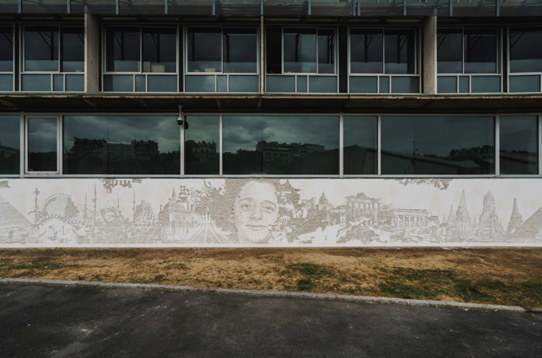
·Paris
Paris, wall, 2023
Vhils uses carving, planing and spray paint to reveal hidden history and characters on the surface of urban buildings, allowing forgotten urban memories to resurface. Vhils challenged the fixed narrative of the urban landscape by stripping off the surface of the wall, breaking the visual-centered experience and making the city a more open and diverse space. In this work, the artistic method of urban relief inspired me.

Relief art plays the role of memory archiving in urban space, allowing the city's past to be perceived by different people in the present. Vhils challenged the fixed narrative of the urban landscape by stripping off the surface of the wall, breaking the visual-centered experience, and making the city a more open and diverse space.

Inspired by this, our design is also committed to reconstructing the way of perceiving the city. Through tactile relief, we transform traditional visual information into a touchable experience, allowing visually impaired people to actively explore and understand London's skyline, rather than just relying on second-hand descriptions from the outside world. We carved the foam board in layers, using carving, perforation and other methods to create different textures, trying to let people with disabilities touch and feel the city. Our design further expands the accessibility of public space, allowing visually impaired people to experience and feel the city equally and build their own spatial cognition in the exploration. In this process, we are not only redefining the way to experience the city, but also promoting the city to become a truly inclusive and multi-sensory accessible environment, so that everyone can build their own unique urban memory.

